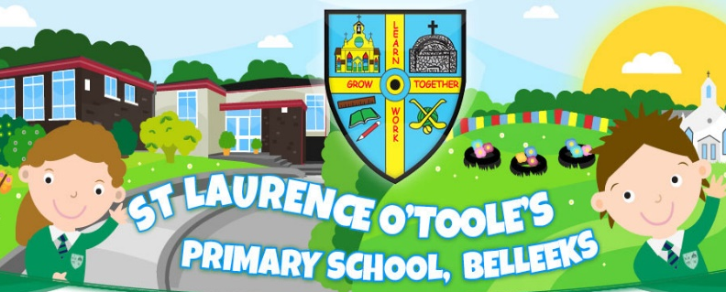
St. Laurence O’Toole’s
To all my teachers, teacher assistants, priests and coaches at St. Laurence o’ Toole’s Primary school….
Thank you for helping me learn how to make my brain bigger and healthier by talking me through with all of the things I couldn’t do if weren’t for you I wouldn’t the person I am today, in fact I wouldn’t I wouldn’t be writing this. Thank to Mrs. Mc Grath I wouldn’t have know how to share, read, write or know how to say the alphabet or know the difference between right and wrong so thank you. Thanks to Mrs Toner I wouldn’t know how to write stories, know how to put punctuation in all the right places the most important thing of a story. I wouldn’t know any math such as subtraction and addition. Thank you. Thanks to Miss O’ Neil I wouldn’t have known how to use any technology such as using Microsoft Word, Power point. I also wouldn’t know how to do multiplication and division. You also helped me prepare for my communion and first confession Thank you. Thanks so much to Mrs. Friel, Mrs. Hughes, Mrs. Mc Ateer and not forgetting Mr. Phillips all of you have taught me so much. Most importantly you helped have the courage and confidence to help me move to high school, some may find it difficult and hard but you have made so easy for me, and I think I speak for every primary seven that has ever been in St. Laurence o’ Toole’s. Thank you. These are just a couple of small thank you to the teacher assistants, Fr. Murphy, Mickey, Fiona and Greg Mc Cabe.
To Mrs. Gorman and Mrs. O’ Neil thanks to you two if I ever fell on the ground and you two weren’t there lets just there would have been a lot more crying and blood. When I broke my wrist Mrs. o’ Neil came rushing over to save and I am so thankful you did because if you didn’t, I would’ve rolled on down the hill into the steel fence. When I ran into the wall and hit my head and hit my knee on the tarmac Mrs Gorman was there to save me, I am also thankful you did because I could’ve passed out and went unconscious but you made sure that didn’t by keeping me talking. So, thank you both of you. To Fr. Murphy thanks to you I have made my communion and first confession. Thank you so much. Thank you, Mickey, for keeping me fit, active and healthy. Thanks for teaching me new games such as rounders, shark attack and dodgeball. Thank you. Thank you, Greg, for teaching me the proper ways of Gaelic and bringing out my best place on the field. Thank you. Fiona what can I say well all I can say is you always made my tummy full. You also kept me company about anything we could think of I would try and explain all of it but there is just too much, but anyway Thank you.

I just want to say one huge thank you to each and every single person who has made my seven years of primary school fun and full of happiness.

THANK YOU!!

