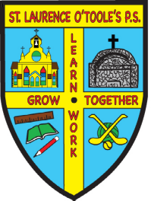 St. Laurence O’Toole’s P.S.

31 Main Street Belleeks Newry Co. Down BT35 7PH

PRINCIPAL: Mrs. B. Friel Tel: 028 30 878387
Fax: 028 30878387

Email: info@stlaurences.belleeks.ni.sch.uk
Website: www.stlaurenceotooles.co.uk

June 28th, 2021

Dear Parents,

As my last few days draw to a close, I simply want to thank you all from the bottom of my heart for your continuous support over my years as a teacher and Principal.

I have been riding a rollercoaster of emotions these last few weeks and am completely overwhelmed by your kindness and generosity. Unfortunately, due to Covid, we were unable to have a large gathering in school so please accept my sincere thanks for all the beautiful gifts and well wishes. As usual, you have really gone over and above!!!!

Dear Pupils,

I have loved working in this school and it’s all down to each and every one of you. We’ve had happy times, sad times, busy times, fun times and most of all we’ve shared many great memories which I will cherish forever. Make sure you all have a lovely Summer and the Staff look forward to welcoming you back in September.

No doubt, you will hear from the newly appointed Principal in due course.

Take care everyone and God Bless you all.

Yours sincerely,

Brea Friel

